#### CHAPTER 4

*The Studio System*

MANUFACTURING DREAMS

#### Movies and Mass Production

When Hortense Powdermaker, in her 1950 anthropological study of the movie colony, described Hollywood as “a dream factory,” she put into words the essential contradiction that lies at the heart of the American cinema: it is both an art and an industry. It manufactures images, sounds, characters, situations, and stories. Film is a product of the so-called second Industrial Revolution, the late nineteenth-century upheaval that took place in the scientific technologies of electricity, steel, chemistry, and communications. The cinema arose as a result of the scientific research and technological development of American industry—from Thomas Edison’s machine shops that produced the motion picture camera; George Eastman’s photographic works that innovated motion picture fi lm; and the research labs of Bell Telephone, Western Electric, American Warner Bros. lot.

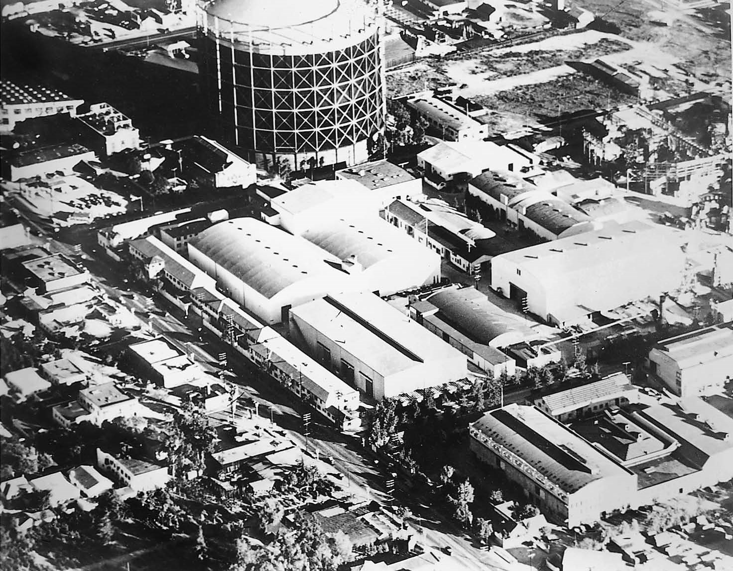

Author’s collection

The studio as a factory: an overview of the Telephone & Telegraph, General Electric, and Westinghouse that pioneered the basic sound recording and transmission technologies, ranging from the telephone and telegraph to the phonograph and radio, which provided the foundation for the silent motion picture’s subsequent transition to sound.

At the same time, the motion picture industry is genuinely an industry in that it draws on the techniques of modern mass production—the centralization of production, the division of labor, the increasing specialization and professionalization of the workforce, and the assembly line. Even before the studio era, fi lm companies such as Edison and American Mutoscope relied on cheap, sweatshop labor (consisting mostly of women) to operate fi lm-drying drums, to retouch negatives, to handpaint (or tint and tone) sequences from films, and to assemble prints for distribution.

The development of the studio system in the 1910s and 1920s was based on industrial models developed by Henry Ford and others to streamline the production process. Although the motion picture does not pass from hand to hand on a continuously moving conveyor belt (like the machine parts in the comic assembly-line sequence of Charlie Chaplin’s *Modern Times,* 1936), it nonetheless depends on the coordinated efforts of each member of the production team, including not only highly paid producers, directors, and stars but also other workers from the middle and lower end of the salary scale, such as screenwriters, art directors, costume designers, camera people, carpenters, and electricians.

Like other machine-based industries, the motion picture industry relies on an elaborate, heavily capitalized system of production, employing precision, state-of-the-art machinery and hundreds, if not thousands, of skilled workers whose efforts are carefully coordinated by a centralized management. Its efficiency is based on what Powdermaker views as a totalitarian dictatorship over the means of production—the control of raw materials (including not only mechanical equipment but also, in the unique case of motion pictures, talented artists), the standardization of the production operation, and the implementation of modern mass-distribution and marketing strategies that maximize the accessibility of the product for the consumer and minimize competition from others. It is no accident that the motion picture business is referred to as an industry and that motion picture studios are called, by Powdermaker and others, factories.

#### Intangible Goods

As Powdermaker’s phrase “dream factory” suggests, the products of this system of mass production resemble, yet are different from, the typical products of American industry. It does not make cars, household appliances, toothpaste, or laundry detergent; it manufactures dreams. But those dreams are mass-produced and they are the product of the studio, not the spectator. The consumers of motion pictures do not purchase a durable good, that is, a commodity designed to last for three or more years. Nor do they purchase a nondurable good, an item that is intended to be used up more quickly. Instead, they purchase an intangible good, an entertainment experience that lasts for a few brief hours and then vanishes into memory.

Other machine-based industries produce standardized merchandise. Each bar of Ivory soap, each box of Total cereal, each 2012 Ford Taurus is more or less identical to each other bar, box, or car bearing the same name. Such items can be distributed and sold as products to a public that knows, more or less, what it is getting. Once manufacturers have established the brand names of their wares, through advertising or other means, they can predict with reasonable certainty how their products will fare in the marketplace. In this way, they are able to avoid excessive underproduction or overproduction and thus stabilize their operations.

Motion pictures, however, are unique products, never before seen by an audience. Though films, in general, have enjoyed a relatively stable following (from the 1920s through the 1940s, at least), each individual fi lm is an unproven commodity for which there is no built-in, guaranteed audience. As a result, producers take a gamble each time they make a fi lm. The fact that a previous fi lm has done well at the box office in no way ensures the success of the next fi lm. The studio system evolved to reduce the risks inherent in the production of intangible goods such as motion pictures. Its business practices developed in the way that they did in order to stabilize an unstable business.

Hollywood generates its own form of brand names—the star system; the identifiable personalities of well-known producers, directors, and screenwriters whose names attract audiences; and the familiar visual iconography and story patterns of fi lm genres. In this way, the studios attempt to provide audiences with a variety of fundamental known quantities that can serve as a basis for selling a larger, essentially unknown quantity. At the same time, producers engage in an assortment of monopolistic business practices—such as blind bidding; block booking; and runs, zones, and clearances—to ensure that whatever films they do make will provide them with a secure return on their investment.

THE MAJORS AND THE MINORS

In its heyday (1930s–1950s), the studio system was dominated by five major and three minor studios, most of whom continued to play a significant role in Hollywood long after the demise of the studio system. In fact, many of them still dominate the fi lm industry today. The majors included Paramount, Loew’s/ Metro-Goldwyn-Mayer (M-G-M), Fox/20th Century-Fox, Warner Bros., and Radio-Keith-Orpheum (RKO); the minors consisted of Universal, Columbia,and United Artists. These studios came into being over a relatively short, 16-year period stretching from 1912 (Universal) to 1928 (RKO). (Though 20th Century-Fox was not created until 1935, the Fox Film Corporation on which it is based was founded in 1915.) Paramount was founded in 1914, Columbia Pictures in 1922, Warner’s in 1923 (though it came into existence as a distributor in 1917), and M-G-M (formerly Metro, 1919) in 1924.

#### Origins

The studio system took the place of an earlier organization, Thomas Edison’s Motion Picture Patents Company (MPPC), a trust that, through its control of basic motion picture patents, governed production, distribution, and exhibition. The structure of this trust was oligopolistic; that is, it was controlled by a handful of companies, including Edison, Vitagraph, Pathé, Biograph, and others. The origins of the studio system can be traced to the attempts by independent exhibitors and distributors, such as William Fox and Carl Laemmle, to break up this trust. They finally succeeded in doing this in 1915, when U.S. courts declared the MPPC to be in violation of the Sherman Antitrust Act.

The trust had served to stabilize the industry during the nickelodeon era. Its overthrow led to the establishment of another stabilizing system, designed to suit the needs of an expanding fi lm industry. The trust oversaw an industry in which short, one-reel films were sold, like sausages, by the foot. The dramatic content of the films played little or no part in their marketing strategy. Though the actors in trust pictures were occasionally identified in the trade press as early as 1909, the trust resisted publicizing its stars in the popular press in a deliberate attempt to prevent the creation of a costly star system, similar to that which had developed in the legitimate theater.

Independents such as Fox and Laemmle fought the trust both in the courts and in the theaters, where they gave the public what it seemed to want— feature-length films with sensational dramatic content and stars. In particular, the formation by Adolph Zukor in 1912 of the Famous Players Company, which boasted motion pictures with “famous players from famous plays,” capitalized on these two selling points to differentiate its product from the trust’s more anonymous and less distinguished fare. The studio system arose to maximize the exploitation of feature-length films and the star system, dramatic innovations that the trust had ignored. But the studio system’s greatest strength, as an institution, lay in its development of a vertically integrated marketplace, which virtually ensured its economic future.

#### Vertical Integration

The term “vertical integration” refers to the structure of a marketplace that is integrated (rather than segregated) at a variety of crucial levels; in the case of the motion picture industry, the studio system established a market in which the studios are owners of their production facilities, distribution outlets, and theaters. In other words, the studios control multiple levels of the marketplace from the top down, from production to exhibition.

Vertical integration began in the 1910s, when the trust denied motion pictures to independent exhibitors such as Fox, who refused to pay arbitrary weekly license fees to the trust to operate his theaters, and to independent distributors like Laemmle, who resented the trust’s stranglehold on the supply of product, which his exchanges purchased and then rented to exhibitors. Their search for product to distribute and exhibit led them into production themselves. Vertical integration inspired the postwar consolidation of the studio system as national distribution companies, such as Paramount, merged with production companies, such as Famous Players and Lasky, and subsequently began to purchase theater chains; and as exhibitors such as First National added distribution and production to their overall operations.

The creation of M-G-M in the mid-1920s is an example of the vertical integration that was taking place during this period. In 1920, Marcus Loew, who owned an extensive chain of theaters, entered production and distribution by purchasing a small company called Metro Pictures. Early in 1924, Loew obtained another independent production company, Goldwyn Pictures, and, later that year, purchased the Louis B. Mayer Picture Corp., whose chief assets consisted of Mayer and his star producer, Irving Thalberg. The result of Loew’s expansion was Metro-Goldwyn-Mayer, a fully integrated corporation that extended its control of motion picture product through the production, distribution, and exhibition stages.

All of the major studios owned theater chains; the minors—Universal, Columbia, and United Artists—did not. The minors distributed their pictures, by special arrangement, to theaters owned by the majors; and the majors regularly booked one another’s films in their theaters. Vertical integration results in a fairly efficient economic system. The major studios produced from forty to sixty pictures a year—enough films to supply their own and even other studios’ theaters.

The formation of M-G-M via a merger of Metro Pictures, Goldwyn Pictures, and Louis B.

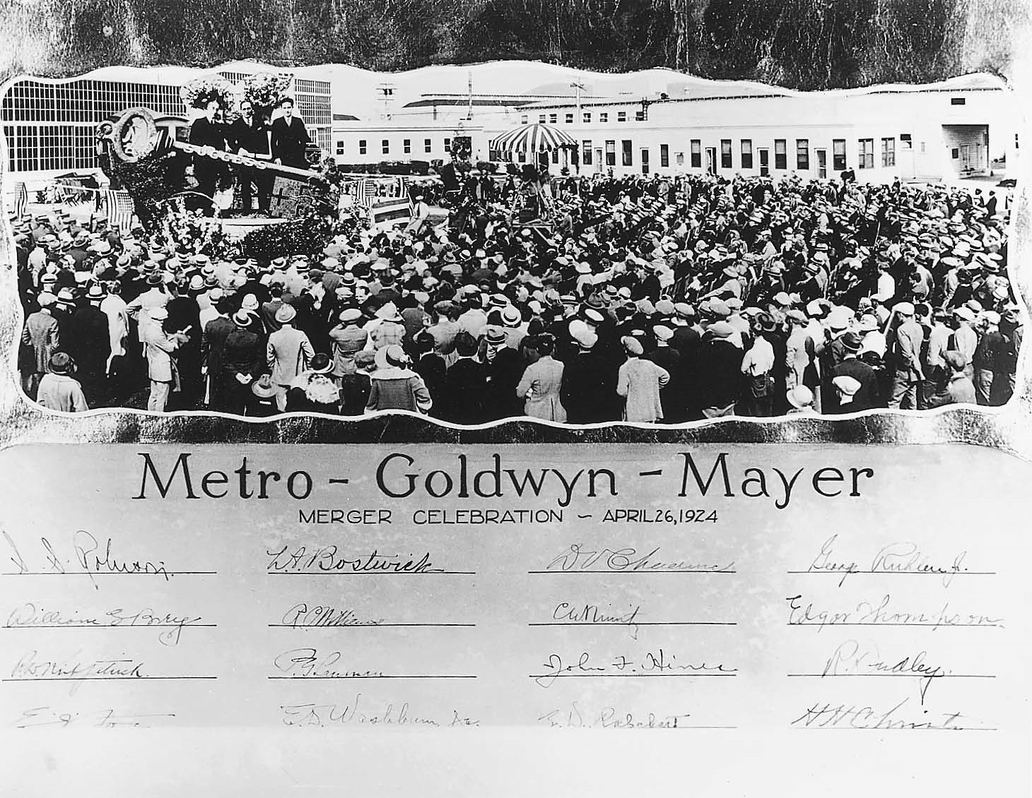

Author’s collection

Mayer Picture Corp. in 1924.

The majors owned only a fraction of the nation’s t heaters—in 1945, for example, they owned 3000 of the 18,000 theaters around the country. The remainder were owned and operated by theater chains or independents. But the theaters owned by the majors tended to be large, first-run houses, situated in the biggest cities. As a result, these theaters generated over 70 percent of all box-office receipts.

#### Block Booking, Blind Bidding, and Runs, Zones, and Clearances

The majors ensured the profitability of their own theaters and controlled the independents by instituting a series of special distribution practices known as block booking, blind bidding, and runs, zones, and clearances. Block booking refers to the rental of multiple films in a single package. If exhibitors wanted to rent any one fi lm, they had to rent others in the package as well. And since they had often contracted with distributors for films before the films were actually made, they were forced to bid for many of them without seeing them—a procedure called blind bidding.

These practices evolved out of the power of the star system. Paramount insisted that theater owners who wanted to book a popular Mary Pickford or Douglas Fairbanks picture take other pictures as well, including cheaply made films that featured no stars. In this way, Paramount could sell the bad with the good, ensuring that even its worst films would find a market. The studios protected their own first-run theaters from the competition of independents and attempted to get the most rental income from first-run independent theaters by implementing a system of runs, zones, and clearances. As a result of this system, a fi lm that opened in the first-run movie palaces in early September would not get to play in the cheaper neighborhood theaters until late October or early November. New films would initially be rented only to first-run theaters—to large houses that generated the lion’s share of box office receipts. The majority of these tended to be owned by the studios. At the same time, distribution was guided by a system of zones; only one theater in any particular area was permitted to exhibit a new picture. This practice also tended to favor studio-owned theaters.

Finally, smaller second-run and sub-run theaters were forced to wait until a picture had completed its run in the larger houses before they could obtain it. As a fi lm moved through successive runs, clearances of between 7 and 30 days were observed, during which time the fi lm was unavailable. This practice reinforced the hierarchical structure of exhibition and protected each tier of theaters from competition with theaters farther down the scale that charged audiences less for tickets. Delays between runs were designed to renew demand for the picture but they also tended to favor studio theater chains over independent exhibitors.

These practices, which were subsequently outlawed by the courts, effectively prevented independent producers from entering the marketplace and competing with the eight major studios by arming the latter with contractual advantages that enabled them to control first-run exhibition. Without access to first-run exhibition, independent producers could not make a profit on their films. These procedures also served to squeeze the maximum rental income out of the marketplace. Independent producers of first-run films—such as David O. Selznick, Walt Disney, Samuel Goldwyn, Walter Wanger, Howard Hughes, Alexander Korda, and others—worked effectively *within* the studio system, largely by distributing (and occasionally financing) their films through existing studios such as United Artists, which had been established in 1919 for just such a purpose.

STUDIO PRODUCTION: FROM STORY IDEA

TO AD CAMPAIGN

#### Under Contract

The efficient organization of distribution and exhibition operations was matched by that of actual film production. The oligopolistic control by a small cartel of major studios extended to production personnel, who were contracted to various studios or producers and who existed as a pool of resources from which studios could draw at any time. Actors and actresses functioned as commodities, much as baseball players and the members of other professional athletic teams did. Unlike the stars of the silent era who secured short-term contracts for two or three pictures, studio stars worked under restrictive, long-term, seven-year contracts, which forbade their engaging in non-approved acting activities (such as the theater, radio, and television) and regulated their personal behavior, demanded that they adhere to a morals clause, and even governed other features of their off-screen appearance, including their hair styles, choice of clothing, and weight.

The *1937 Academy Players Directory Bulletin* provides a photo gallery of that year’s contracted and non-contracted players, listing them by category and including their studio affiliations. The categories for women range from “Ingenues” (Lucille Ball, RKO-Radio) and “Leading Women” (Marlene Dietrich, Paramount) to “Characters and Comediennes” (Gracie Allen—of George Burns and Gracie Allen fame, Paramount). Male categories range from “Younger Leading Men” (John Wayne, Universal) to “Leading Men” (Spencer Tracy, M-G-M) and “Characters and Comedians” (Edward Everett Horton, Universal). At the back of the book are “Children” (Judy Garland, M-G-M; Mickey Rooney, M-G-M), “Colored Artists” (Stepin Fetchit, 20th Century-Fox), and “Oriental Artists” (Keye Luke, 20th Century-Fox, who played Number One Son in the Charlie Chan films). The fact that minority performers occupy only five of the *Bulletin* ’s 245 pages indicates their marginality in the studio system.

Studio contracts required contract players to act in whatever films the studios cast them in (or undergo suspension without pay, which time was added to the seven years of their contract), attend studio publicity functions, publicize their own films, promote product tie-ins, and, occasionally, be loaned out to other studios to fulfill the same obligations there for one or two pictures. During the early 1930s, in particular, the actors’ lives were no picnic. They worked six days a week—often for 14 hours a day. During his first year at M-G-M (1931), Clark Gable appeared in fourteen pictures; during her first year at Warner’s (1932), Bette Davis made eight films. It was tough on directors as well. In the early 1930s, Michael Curtiz (who made *Casablanca* in 1942) directed, on the average, five films a year for Warner Bros.

#### A Self-Contained World

The studio kept most of its workers under contract, including producers, directors, s screenwriters, cinematographers, art directors, costume designers, sound recordists, and other technical staff. With such a sizable pool of talent held in constant readiness for each new project, it was relatively easy to cast a picture and get it into production. The physical layout of the studio was similarly designed to facilitate production. In fact, the studio functioned as a self-sufficient world unto itself—with its own police force and fi re, sanitation, water, and electrical departments, and with its own commissary or restaurant, gymnasium, and infirmary.

A story department housed readers, whose job it was to pore through recent books, magazines, and newspapers in search of story ideas. Nearby stood the offices of studio screenwriters, who prepared story synopses or treatments, wrote dialogue, and generated shooting scripts for stars under contract. These scripts were then analyzed by unit managers or production assistants and broken down scene by scene by assistant directors, who estimated overall budget and shooting time and organized a shooting schedule. This schedule was planned in such a way as to economize on costs.

Scenes from films were rarely shot in the order in which they appeared in the screenplay (in continuity), but rather they were shot out of order. Thus, all the scenes staged in one setting or location were shot back-to-back; scenes containing the same groups of actors or actors who were only available for a short time period were shot together; shots requiring the rental of expensive equipment not owned by the studio, such as special camera cranes, or the use of studio equipment in high demand by other studio production units were shot on a single day; and so forth. Shooting scripts were sent to the casting department, which suggested actors for those roles not already cast by the producer or director.

She scripts were also sent to the art department, which designed the sets and perhaps drew up a storyboard, or a sketch of what scenes would look like, for the use of the art director, costume designer, and cinematographer. Carpenters in the studio workshop built sets according to the instructions of the art director; scenic artists painted them; staff set decorators dressed the set with tables, chairs, and other furnishings provided by the prop department, which stored a supply of such items in the prop room. A wardrobe department was staffed with seamstresses to make alterations in existing costumes, which were stored on the lot (or rented from Western Costume), and to execute designs for new costumes.

The studio’s camera and sound departments provided the necessary equipment for filming scenes and recording dialogue and sound effects (and repaired this equipment when necessary). Additional equipment for the filming of stunts or sequences involving special effects, such as explosions, bullet holes, or fi res, were made in the studio’s special-effects department. Electricians wired the set for both on-camera props (such as table lamps) and off-camera equipment (such as incandescent or arc lamps, cameras, sound-recording equipment, and other machinery to produce special effects such as wind, rain, snow, or fog).

#### The Chain of Command

The coordination of all of these individual efforts was the responsibility of the producer and/or director and their assistants, who relied on the screenplay to serve as a blueprint for production. During shooting, the division of labor was coordinated according to various areas of specialization. The director’s crew— consisting of assistant directors, script girls, dialogue coaches, and second-unit directors—assisted the director. Actors were attended by makeup artists, hairdressers, lighting doubles, and stand-ins. The photography unit— consisting of camera operators, grips, and electricians—assisted the cinematographer; and the sound unit, including boom operators and technicians who laid cables and placed microphones, facilitated the job of the sound recordist.

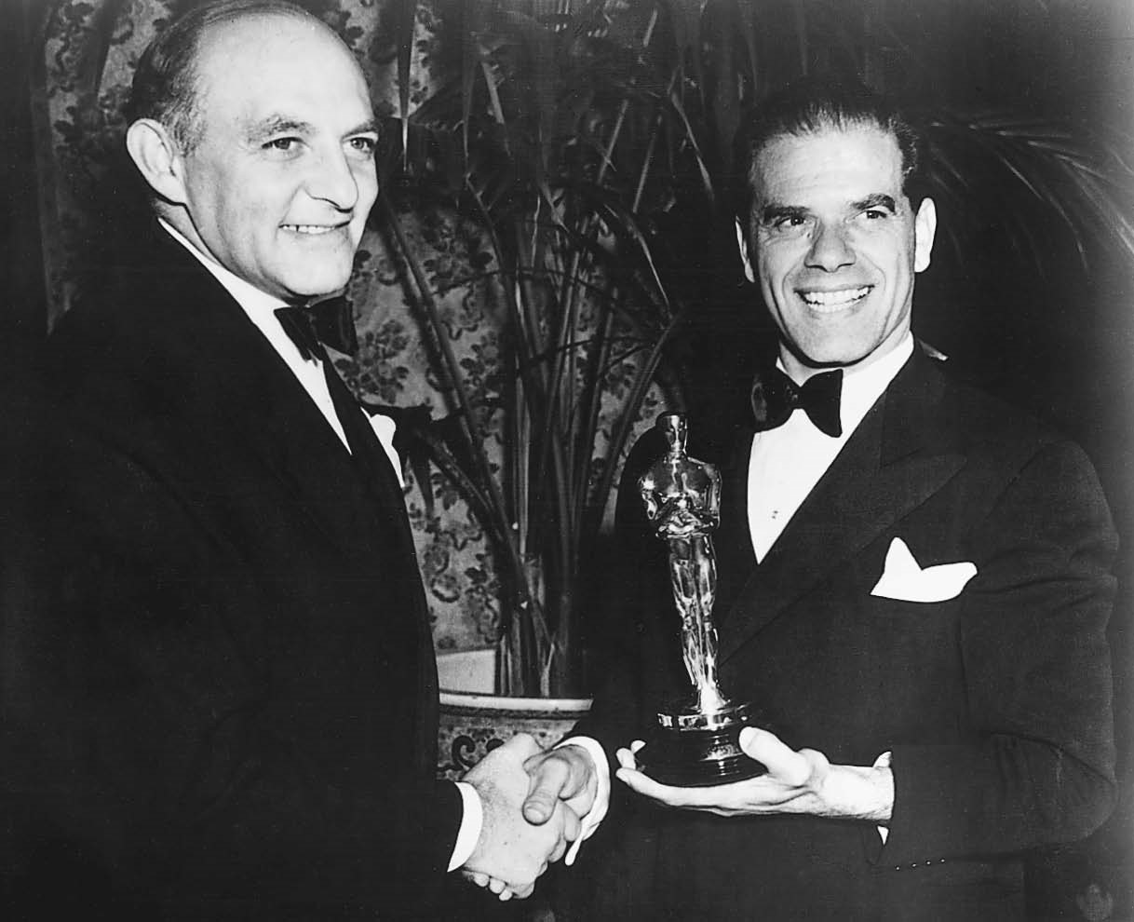

Author’s collection

Harry Cohn (*left*), head of production at Columbia, and Frank Capra share an Academy Award for Best Picture for *You Can’t Take It With You* (1938).

After filming, editors prepared a rough cut of the fi lm that was synched with dialogue and sound effects. To this was added a musical score written by a studio composer and recorded by the studio orchestra. The montage department assembled montage sequences, which condensed the passage of time or space (as seen in montages of newspaper headlines summarizing the course of events over time or in travel montages conveying the characters’ European vacation through stock shots of the House of Parliament in London, the Eiffel Tower in Paris, and the Coliseum in Rome); the studio’s own laboratory added optical effects, such as fades, dissolves, or wipes; and the titling department prepared the credit sequence and any intertitles to be inserted in the fi lm.

At the top of the production process stood the studio’s chief executive or head of production—Jack Warner at Warner Bros., Darryl Zanuck at 20th Century-Fox, Louis B. Mayer at M-G-M, or Harry Cohn at Columbia. Actual production was supervised by a team of unit producers such as Irving Thalberg, Harry Rapf, Eddie Mannix, Hunt Stromberg, and others at M-G-M during the early 1930s. These producers selected story properties and planned a program of films to be put into production for the year; the unit producer was responsible for selecting a director, helping in the casting of the fi lm, and supervising the preproduction, production, and postproduction phases, including the final editing of the film.

Next in command was the director. Certain major directors worked with the producer and screenwriter in preproduction, consulting on the preparation of the script and the casting of actors. Other directors might have been assigned to the picture only a few days before actual shooting was to begin. In the former case, the director consulted with the art director and costume designer in working out the overall design of the fi lm. In either instance, the director was responsible for rehearsing and directing the actors, staging the action, and giving instructions to the cinematographer on how each shot should look in terms of lighting, camera angle and distance, and camera movement. After shooting was completed, the director supervised postproduction, working with the editor, sound mixer, and composer on a version of the fi lm that might be screened for audiences at a sneak preview. In general, the unit producer had final say on changes made to the film between the preview and its release to theaters.

During production and just prior to the film’s release, the publicity department orchestrated promotion for the fi lm in the media, designing posters and ad campaigns as well as supervising the production of publicity photographs and pressbooks to be sent to newspapers, magazines, and exhibitors, as well as trailers to be run in theaters.

STUDIO STYLE

The structure of the studio resulted not only in the streamlining of the production process but also in the creation of a studio style or look. The seven-year contract kept actors, producers, directors, art directors, cinematographers, and composers at individual studios for decades. Gable remained under contract at M-G-M from 1931 to 1954. Producers Henry Blanke and Bryan Foy worked for Warners from 1928 through the mid-1950s. Cecil B. De Mille directed films for Paramount for over forty years, from 1914 (*The Squaw Man*) to 1956 (*The Ten Commandments*) —except for one brief six-year stretch (1925–1931) when he worked first as an independent producer and then at M-G-M, where he made his first sound films. Michael Curtiz and Roy Del Ruth directed films for Warner’s from 1926 to 1953–1954.

Cedric Gibbons supervised art direction at M-G-M for over thirty years, from 1924 to 1957; Anton Grot served as a production designer for Warner Bros. from 1929 to 1950; and Hans Drier worked more or less exclusively for Paramount from 1924 to 1951. Arthur Miller was a director of photography at Fox from 1932 through 1950; William Daniels, Greta Garbo’s cinematographer of choice, was under contract to M-G-M from 1923 to 1946; and Charles B. Lang shot films at Paramount from 1926 to 1952. Alfred Newman scored films for 20th Century and 20th Century-Fox from 1934 to 1962; Max Steiner did the same for both Warner Bros. and RKO from 1929 to 1956.

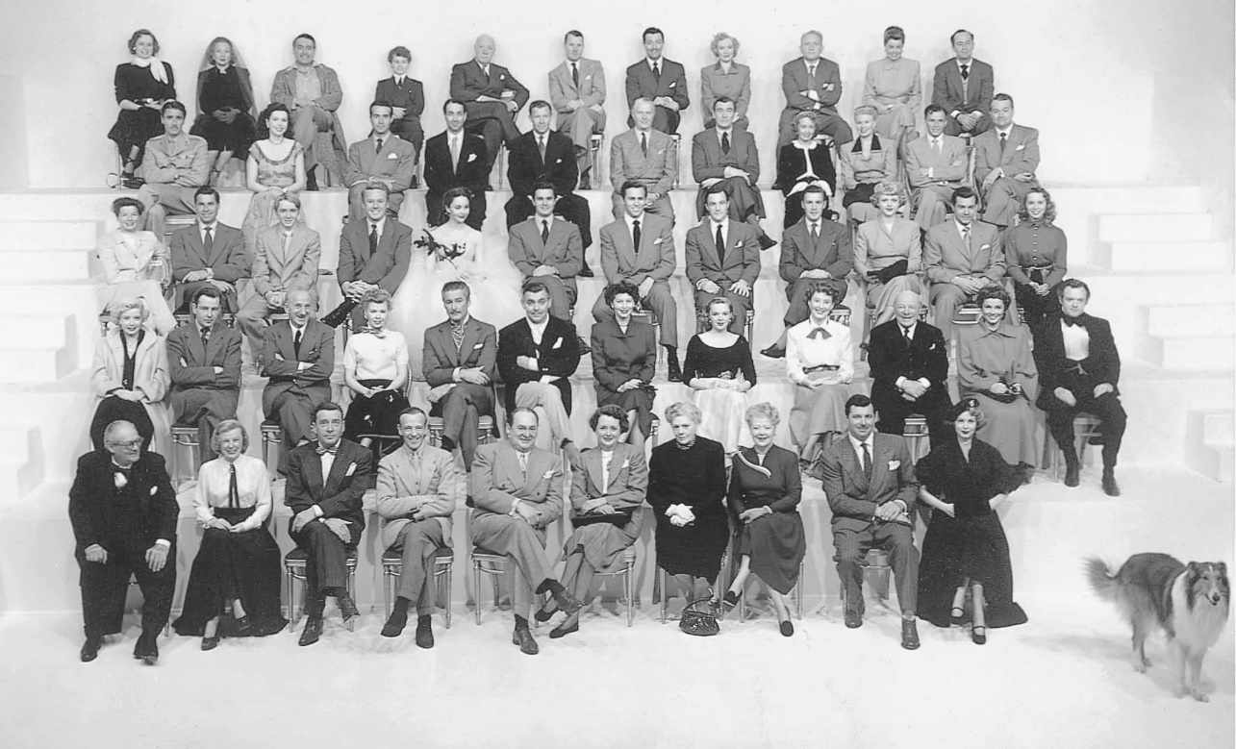

Author’s collection

M-G-M’s stable of stars in 1948–1949. Ricardo Montalban (row 4) represents the studio’s postwar nod to diversity.

*1st row (left to right for all rows):* Lionel Barrymore, June Allyson, Leon Ames, Fred Astaire, Edward Arnold, Mary Astor, Ethel Barrymore, Spring Byington, James Craig, Arlene Dahl, Lassie *2nd row:* Gloria De Haven, Tom Drake, Jimmy Durante, Vera-Ellen, Errol Flynn, Clark Gable, Ava Gardner, Judy Garland, Betty Garrett, Edmund Gwynn, Kathryn Grayson, Van Hefl in *3rd row:* Katharine Hepburn, John Hodiak, Claude Jarmon, Jr., Van Johnson, Jennifer Jones, Louis Jourdan, Howard Keel, Gene Kelly, Alf Kjellin, Angela Lansbury, Mario Lanza, Janet Leigh *4th row:* Peter Lawford, Ann Miller, Ricardo Montalban, Jules Munchen, George Murphy, Reginald Owen, Walter Pidgeon, Jane Powell, Ginger Rogers, Frank Sinatra, Red Skelton *5th row:* Alexis Smith, Ann Sothern, J. Carroll Naish, Dean Stockwell, Lewis Stone, Clinton Sundberg, Robert Taylor, Audrey Totter, Spencer Tracy, Esther Williams, Keenan Wynn

The presence of these and other contract personnel contributed to the unique stylistic and thematic personality that each studio constructed for itself during different periods of the studio era. As a result, the studio system permitted each studio, by focusing on certain kinds of genre story types and establishing an individual style, to differentiate its product from that of the other studios. A comparable system of product differentiation exists today on television. Cable channels provide viewers with markedly different programming; there are, for example, shopping, food, weather, news, sports, children’s, classic movie, and new movie channels. The studios functioned in a somewhat similar way. Along with their movement toward the standardization of production, which was built into the structure of the studio system, there was a complementary drive for product differentiation.

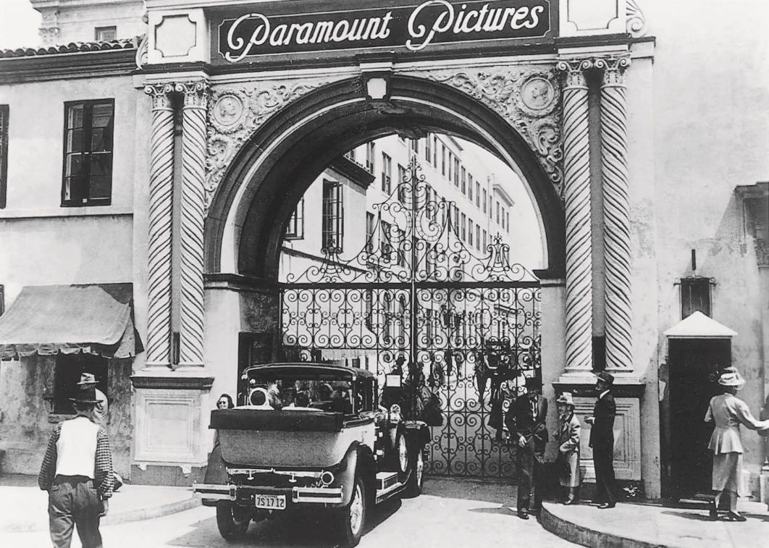

Courtesy of Paramount

The famous Bronson Gate, as seen in Paramount’s *Sunset Blvd.* (1950).

#### M-G-M and Paramount

The most visible form of product differentiation was the star. M-G-M, which boasted “more stars than there are in heaven,” developed a roster of glamorous actresses who dominated the screen from the late 1920s to the 1940s. Greta Garbo, Joan Crawford, Norma Shearer, Louise Rainer, Myrna Loy, and Greer Garson brought sincerity, refinement, and sophistication to their screen roles. (There were, of course, exceptions to M-G-M’s image of polish and gloss, for the studio was also home to the more earthy Marie Dressler and to Lassie; it was also the producer of Tod Browning’s *Freaks,* 1932, which functioned as a kind of *Grand Hotel* for freakish circus attractions.) By contrast, Paramount’s leading ladies—such as Clara Bow, Marlene Dietrich, Mae West, Claudette Colbert, and Carole Lombard—combined sexual savoir-faire with tongue-in-cheek wit.

The difference between the two studios can best be illustrated by contrasting the anarchic, pretension-deflating comedies made by the Marx Brothers for Paramount (such as *Animal Crackers,* 1930; *Monkey Business,* 1931; *Horse Feathers,* 1932; and *Duck Soup,* 1933) with the more sober, restrained, and calculated comedies they made a few years later for M-G-M (*A Night at the Opera,* 1935; *A Day at the Races,* 1937; and *Room Service,* 1938). Even Paramount’s Jeannette MacDonald, who co-starred with Maurice Chevalier in a series of Ruritanian musical romances, shed her self-irony and penchant for sexual innuendo when she moved to the more restrained operettas at M-G-M, where she teamed up with the decidedly less continental Nelson Eddy.

Paramount’s deft European stylishness, epitomized in the subtle ironies of Ernst Lubitsch’s comedies (such as *The Love Parade,* 1929; *Monte Carlo,* 1930; *Trouble in Paradise,* 1932; and *Design for Living,* 1933) and in the exotic erotic fantasies concocted by Josef von Sternberg for Marlene Dietrich (such as *Morocco,* 1930; *Shanghai Express,* 1932; and *The Scarlet Empress,* 1934) had its counterparts in the earnest celebration of American middle-class family values in M-G-M’s series of Andy Hardy comedies and teen musicals, starring Mickey Rooney or Judy Garland or both ( *Babes in Arms,* 1939, and *Strike Up the Band,* 1940) and in the solid seriousness of prestige melodramas such as *The Good Earth,* 1937; *Boys Town,* 1938; *Mrs. Miniver* and *Random Harvest,* 1942; and *Madame Curie,* 1943.

Warner Bros.

In contrast to the middlebrow style and content of M-G-M, Warner Bros. earned its reputation as the working man’s studio. Photographic style at M-G-M was carefully polished; that at Warner’s looked hasty and rough and conveyed a gritty realism that suited the studio’s narrative interests. Warner’s specialized in gangster films, such as *Little Caesar* (1930), *The Public Enemy* (1931), *The Petrified Forest* (1936), and *The Roaring Twenties* (1939), starring tough-guy performers such as James Cagney, Edward G. Robinson, and Humphrey Bogart, whose proletarian acting styles matched the looks and sounds of the ethnic characters they were asked to play.

Even the swashbuckling action heroes played by Errol Flynn in Warner’s costume dramas championed the downtrodden lower echelons of society— the unjustly imprisoned doctor-turned-pirate in *Captain Blood* (1935) and the title character in *The Adventures of Robin Hood* (1938). Exposés such as *I Was a Fugitive from the Chain Gang* (1932), *Wild Boys of the Road* (1933), and *Confessions of a Nazi Spy* (1939) were ripped from the headlines of the tabloids and pitched, like these newspapers, at a lower- and lower-middle-class audience. Warner’s actresses (such as Ruby Keeler, Joan Blondell, Bette Davis, Olivia de Havilland, Ida Lupino, Ann Sheridan, and Lauren Bacall) played girls-next-door, gold diggers, molls, and down-to-earth dames who could trade wisecracks with the guys without losing their femininity.

#### 20th Century-Fox

Warner’s pitched its product to an urban audience, tailoring its crime films, mysteries, films noirs, musicals, and even costume pictures to blue collar workers and shop girls who appreciated hard-hitting films with a

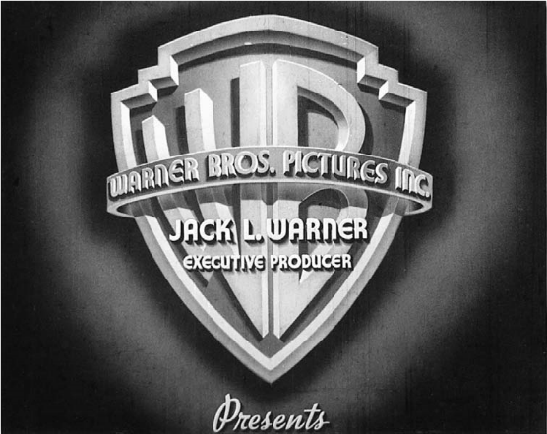

© Photofest

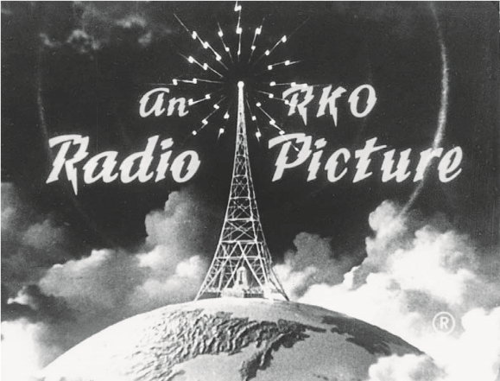

© Photofest

Studio logos: the Warner Bros. shield. The RKO radio tower.

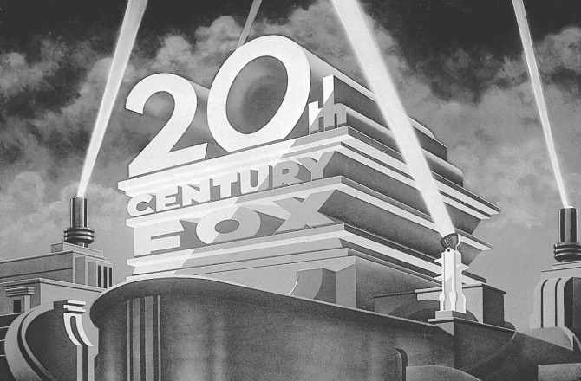

© Shooting Star

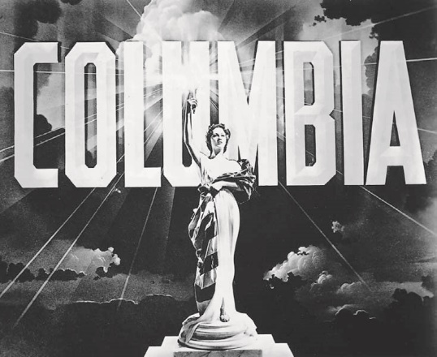

Photofest

The Fox searchlight. Columbia’s lady with a torch.

social conscience. 20th Century-Fox—jokingly referred to by rival studios as “16th Century-Fox” because of all the period and costume pictures it produced—targeted a rural rather than an urban audience. Major Fox stars of the 1930s, such as Will Rogers, Stepin Fetchit, Shirley Temple, and (in the late 1930s) Henry Fonda, spoke to an agrarian, preindustrial, populist concern for homespun, grassroots values. Even Fox stars of the 1940s, such as Tyrone Power, Betty Grable, and Don Ameche, were all-American types who bore no traces of the urban ethnicity found in Warner’s stars such as Robinson, Cagney, and even Paul Muni.

Fox, which was run by an Irish Catholic former cop named Winfield Sheehan and then by a Methodist from Nebraska named Darryl Zanuck, was also known as “the goy studio” because, after the ouster of its founder William Fox in 1930, it was the only studio that was neither owned nor operated by Jews (though the Jewish Joe Schenck did serve as chairman of the

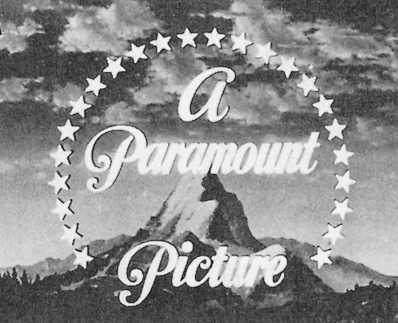

Photofest

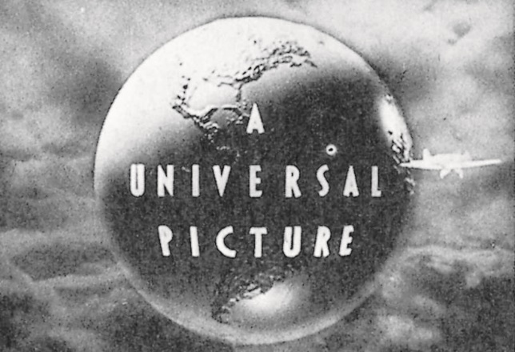

Photofest

Universal’s globe. The Paramount mountain.

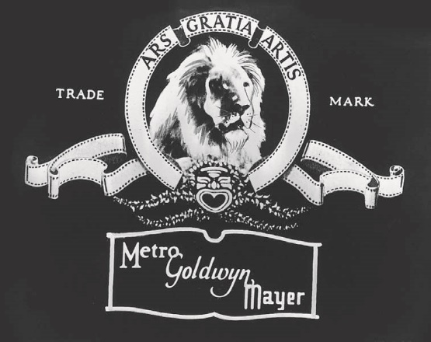

Rutgers Cinema Studies



Photofest

United Artists. The M-G-M lion.

board and executive producer during Zanuck’s reign). This image only served to reinforce the studio’s appeal to nonurban audiences in the Midwest and the South. Ironically, while Jewish executives at Paramount, M-G-M, Warner’s, Columbia, Universal, and elsewhere rarely dealt with subject matter that might be considered Jewish or that openly condemned anti-Semitism at home or abroad, Zanuck, perhaps because of Fox’s reputation as a Christian studio, was one of the first studio heads to sponsor an exposé of anti-Semitism in his production of *Gentleman’s Agreement* (1947), starring Gregory Peck. Zanuck discovered that there was a market for films with a certain social consciousness and prided himself on his productions of John Steinbeck’s *The Grapes of Wrath* (1940), which dealt with exploited migrant farm workers; Erskine Caldwell’s *Tobacco Road* (1941), a drama about the plight of sharecroppers; *The Ox-Bow Incident* (1943), a Western in which vigilantes lynch the wrong man; *Boomerang* (1947), an exposé of legal corruption; *The Snake Pit* (1948), a story about mental illness that looks at the brutal conditions in American mental asylums; and *Pinky* (1949), a film about racial prejudice and a black woman passing for white.

#### RKO

RKO, famous for an unlikely combination of films that range from *King Kong* (1933) to Fred Astaire and Ginger Rogers musicals and *Citizen Kane* (1941), was governed by a succession of different heads of production during the 1930s and 1940s, including David Selznick ( *What Price Hollywood?* and *Bill of Divorcement,* 1932); Merian C. Cooper ( *The Lost Patrol,* 1934); George Schafer ( *Abe Lincoln in Illinois,* 1940; *Citizen Kane,* 1941); Charles Koerner (Val Lewton’s films, such as *The Cat People,* 1942, and *I Walked with a Zombie,* 1943; *The Spiral Staircase,* 1946); Dore Schary, who supervised a number of films noirs ( *Crossfire, Out of the Past,* 1947; *They Live by Night,* 1948); and finally, Howard Hughes ( *I Married a Communist,* 1950; *Vendetta,* 1950; *Jet Pilot,* 1957), whose mismanagement of the studio led to its sale and dismantlement in 1955. Though certain directors (John Ford, George Stevens, Robert Siodmak, Jacques Tourneur) and stars (Katharine Hepburn, Cary Grant, Robert Mitchum) worked for the studio at various times during this period, RKO lacked the thematic and stylistic consistency enjoyed by the other majors. United Artists, which merely distributed the work of independent producers such as Samuel Goldwyn, David Selznick, and Walter Wanger, shared a similar fate.

#### Columbia Pictures

Columbia earned a reputation for witty and urbane screenwriting and served as the home base for much of the screwball comedy talent in Hollywood. It was also the studio where Frank Capra directed populist melodramas (*American Madness,* 1932; *The Bitter Tea of General Yen* and *Lady for a Day,* 1933; *Lost Horizon,* 1937; *Mr. Smith Goes to Washington,* 1939) and comedies (*It Happened One Night,* 1934; *Mr. Deeds Goes to Town,* 1936; *You Can’t Take It With You,* 1938) for over ten years (1928–1939). Capra’s own *It Happened One Night* is generally acknowledged as the first screwball comedy, but Howard Hawks’s contribution to Columbia comedies— *Twentieth Century* (1934), written by Ben Hecht and Charles MacArthur—runs a close second.

Columbia scenarists such as Robert Riskin, Sidney Buchman, Jo Swerling, Vina Delmar, Donald Ogden Stewart, Hecht, and MacArthur lent their big-city cynicism to a string of screwball comedies at Columbia in the 1930s, including John Ford’s *The Whole Town’s Talking* and Gregory La Cava’s *She Married Her Boss,* 1935; Richard Boleslawski’s *Theodora Goes Wild,* 1936; Leo McCarey’s *The Awful Truth,* 1937; George Cukor’s *Holiday,* 1938; Hawks’s *His Girl Friday,* 1940; Alexander Hall’s *Here Comes Mr. Jordan,* 1941; and George Stevens’s *The Talk of the Town,* 1942.

Forced to borrow stars such as Clark Gable, Gary Cooper, James Stewart, and Cary Grant from other studios for Columbia pictures in the 1930s, studio chief Harry Cohn decided to build his own stable of stars in the 1940s, including William Holden (*Golden Boy,* 1939; *Picnic,* 1955); Rita Hayworth (*Cover Girl,* 1944; *Gilda,* 1946; *The Lady from Shanghai,* 1948; *Salome* and *Miss Sadie Thompson,* 1953; *Fire Down Below,* 1957); Kim Novak (*Picnic,* 1955; *Bell, Book and Candle,* 1958); Judy Holliday (*Born Yesterday,* 1950; *The Marrying Kind,* 1952; *The Solid Gold Cadillac,* 1956); and Glenn Ford ( *Gilda,* 1946; *Loves of Carmen,* 1948; *The Big Heat,* 1953; *Jubal,* 1956; *3:10 to Yuma,* 1957).

#### Universal Pictures

The golden age of Universal Pictures took place in the first half of the 1930s when the studio was under the guidance of Carl Laemmle, Jr., who supervised the production of two innovative sound films in 1930: the Academy Award–winning *All Quiet on the Western Front* and a Technicolor musical, *The King of Jazz.* He also launched a series of classic horror films, stretching from Bela Lugosi’s *Dracula* (1931) and Boris Karloff’s *Frankenstein* (1931) to *The Mummy* (1932), *The Invisible Man* (1933), *The Black Cat* (1934), and *The Bride of Frankenstein* (1935). At the same time, John Stahl directed a series of emotionally restrained melodramas— *Back Street* (1932), *Imitation of Life* (1934), and *Magnificent Obsession* (1935)—bringing a sophistication and elegance to the studio that gave way, in the 1940s and early 1950s, to crude program pictures for Abbott and Costello, Ma and Pa Kettle, and Francis, the Talking Mule. Douglas Sirk remade a number of Stahl’s melodramas in the mid-1950s, including *Magnificent Obsession* (1954) and *Imitation of Life* (1959), and brought both prestige and profits back to the studio.

Sirk helped to build Universal’s latest leading man, Rock Hudson, into a star in *Has Anybody Seen My Gal?* 1952; *Magnificent Obsession* and *Taza, Son of Cochise,* 1954; *Captain Lightfoot* and *All That Heaven Allows,* 1955; *Written on the Wind,* 1956; *Battle Hymn,* 1957; and *Tarnished Angels,* 1958. The studio subsequently took over where Sirk left off, pairing Hudson and Doris Day in a series of financially successful sex comedies such as *Pillow Talk* (1959) and *Lover Come Back* (1961).

#### Poverty Row

These eight studios dominated a system that included a number of smaller studios, such as Republic and Monogram, that sprouted up in the early 1930s to make B pictures to accompany the major studios’ more expensively produced A picture on the bottom half of a double bill. The demand for cheaply made B films gave rise to other poverty-row studios, such as Grand National, Producers Releasing Corporation (PRC), Eagle-Lion, and Allied Artists. The advent of broadcast television in the postwar era eliminated the demand for B pictures, although certain producers of teen exploitation films, such as American International Pictures, survived into the 1970s.

COLLAPSE: THE END OF THE STUDIO ERA

#### Divestment, Independent Production, and a Changing Marketplace

The dismantling of the studio system began just before World War II when the U.S. Department of Justice’s Antitrust Division fi led suit against the eight major studios accusing them of monopolistic practices in their use of block booking, blind bidding, and runs, zones, and clearances. Hollywood avoided prosecution by agreeing to refrain from some of these practices, but in 1944 the government, after hearing complaints from independent exhibitors that the studios had persisted in antitrust activity, reopened the suit. The Paramount Case, as the suit was now called, was finally settled in May 1948 when the U.S. Supreme Court ruled against the studios. The majors were forced to divorce their operations from one another, separating production and distribution from exhibition. They were also forced to divest themselves of their theater chains, which were to be sold off or operated by a separate group of owners who had no involvement in production and distribution. United Artists, Columbia, and Universal, though named in the suit as co-conspirators for collaborating with the Big Five studios in these practices, owned no theaters and thus were not subject to this ruling. The major studios delayed the process of divorcement and divestiture as long as possible, maintaining a certain degree of control over their theaters until the mid- to late 1950s. As a result, the initial mechanism or structure that gave rise to the studio system remained more or less in place until roughly 1960.

Other factors contributed to the demise of the studio system, including lengthy postwar strikes against the studios by labor unions, changing patterns in leisure-time entertainment that resulted in a sharp drop in attendance (see Chapter 14, “Hollywood in the Age of Television”), competition with television, and the rise of independent production. After the war, actors and directors went into business for themselves, forming their own production companies. Instead of weekly salaries, they negotiated for lump-sum payments to their privately owned corporations. Instead of being taxed as income, these payments were taxed at a much lower rate as corporate capital gains.

During the war, actor James Cagney had formed an independent production company with his brother William, financing and distributing films through United Artists. In 1946, directors Frank Capra, William Wyler, George Stevens, and producer Sam Briskin formed Liberty Films, which folded after the release of one production, *It’s a Wonderful Life* (1946). Alfred Hitchcock and British theater owner Sidney Bernstein set up Transatlantic Pictures in 1948, releasing *Rope* (1948) and *Under Capricorn* (1949) under that logo. Humphrey Bogart’s Santana Productions, named after his yacht, produced *Knock on Any Door* (1949), *In a Lonely Place* (1950), and several other pictures that were released through Columbia. In 1951, John Wayne set up Batjac, which produced *Blood Alley* (1955), *The Alamo* (1960), *The Green Berets* (1968), and many other pictures starring Wayne. In 1956, producer Harold Hecht, screenwriter-director James Hill, and actor Burt Lancaster created their own company, which produced *Sweet Smell of Success* (1957), *Run Silent, Run Deep* (1958), and three other films. In 1955, Marilyn Monroe set up Marilyn Monroe Productions, which made only two films, *Bus Stop* (1956) and *The Prince and the Showgirl* (1957); both were distributed by 20th Century-Fox.

At the same time, fewer but more expensive films were being made to satisfy a changing market of fewer but more demanding spectators. The era of the blockbuster had begun, and the studio system was not equipped to service that mode of production with any efficiency. As the studios lost their grip on major talent and fewer and fewer films were put into production, the studios deliberately let other contract personnel go, closed down their newsreel and animation departments, rented empty studio space to producers of television shows, and entered television production themselves.

The 1960s saw the ownership of the major and minor studios shift to the hands of conglomerate corporations—such as Gulf + Western, which acquired Paramount; Kinney National Services, which purchased Warner Bros.; and MCA (Music Corporation of America), which bought Universal. Conglomerates did not confine their business activities to manufacturing or distributing a single product but engaged in several unrelated economic ventures. Gulf + Western, for example, manufactured automobile bumpers and owned the Consolidated Cigar Corp., New Jersey Zinc Co., and the South Puerto Rico Sugar Co. It also owned Simon & Schuster (publishers), Sega Enterprises (video arcade games), and Madison Square Gardens Corp. (the New York Knicks and Rangers). In this new economic structure, the making of motion pictures became only one of many corporate activities. Studio assets, ranging from real estate to libraries of older films, were sold so the studios could show a profit and increase the value of the company’s shares for stockholders.

Near the end of the 1960s, a number of studios, including Fox and M-G-M, began to sell off their back lots, which now had more value as real estate than as production space. M-G-M even auctioned off its collection of props and costumes, including one of the surviving five pairs of ruby slippers made for Dorothy in *The Wizard of Oz* (1939). Symbolically, the studio era was over.

#### Starting from Scratch: The New “Studios”

Today, many of the studios of the old studio era exist but do so primarily as the distributors of films produced by a growing number of independents. The current studio system consists of six major media companies that are engaged in fi lm production and distribution; broadcast, cable, and satellite television; publishing; the music industry; theme parks; and even motion picture exhibition (the studios can now own theaters as long as they do not conspire with one another to set prices or engage in other restrictive contract terms). 20th Century Fox dropped its hyphen in 1985 and is now a subsidiary of the Fox Entertainment Group, which is owned by Rupert Murdoch’s News Corporation, which also houses Fox Searchlight. Regency is associated with Fox. Dreamworks SKG and Dreamworks Animation are now an independent production company distributing its films through Paramount and Touchstone Pictures. Paramount Motion Pictures Group, owned by Viacom, includes Paramount Pictures, and Paramount Vantage. Columbia Pictures is a subsidiary of Sony Pictures Entertainment, which is owned by Sony. Sony also runs TriStar Pictures and Sony Pictures Classics, Screen Gems, Triumph Films, and Sony Pictures Animation. M-G-M, which owns United Artists, emerged from bankruptcy at the end of 2010; it is owned by Sony and a group of six investing companies. Universal, which is jointly owned by General Electric and Vivendi, has become part of NBC Universal, which also includes Focus Features. Universal is also associated with Amblin Entertainment, Imagine Entertainment, Mandalay, and Morgan Creek. Warner Bros. is a subsidiary of Time Warner, which also controls Castle Rock, New Line Cinema, and HBO Films. Walt Disney Pictures is part of the Buena Vista Motion Picture Group, which owns Pixar Animation Studio, Touchstone Pictures, Hollywood Pictures, Walt Disney Feature Animation, and Miramax. In addition to these six majors, there are several independent outfits. The Weinstein brothers, former owners of Miramax, formed the Weinstein Company, which runs an independent studio known as Dimension. Finally, Lionsgate Entertainment controls Lions Gate.

The new conglomerates maximize their profits and minimize their risks through synergy, a process of cross-promotion. Time Warner, for example, owns most of the Harry Potter franchise. Though the Harry Potter books are published by a separate entity, Scholastic Books, the Harry Potter films are produced and distributed by Warner Bros., a Time Warner company. AOL, a part of the Time Warner family until 2009, has more than 30 million customers and provides Internet links to information about the fi lm and to Harry Potter merchandise that the company sells. Moviefone, another Time Warner subsidiary, promotes the fi lm and sells tickets for it. Time Warner magazines, ranging from *Time, People,* and *Fortune* to *Entertainment Weekly,* generate news and feature coverage of the films, while Time Warner cable outlets such as Turner Broadcasting saturate the airwaves with trailers and advertisements for the films. Meanwhile, the Warner Music Group markets the soundtracks to the films on CDs and tapes. In effect, the entire Time Warner company pools its efforts to sell Harry Potter.

Each time a new film is made today, a studio must be assembled from scratch to produce it. Screenwriters must be found to produce treatments and shooting scripts; producers, directors, stars, cinematographers, art directors, costume designers, and others must be assembled before production can go ahead; and, most crucial, financing must be secured from banks or other investors. Picture making today takes more time than it ever did; the six-week shooting schedules of the 1930s and 1940s have given way to three- to four-month shooting schedules. Films once made in two or three months now take a year or more to finish. As Billy Wilder once said in the 1980s, “In the old days we used to spend our time making pictures; these days we spend it making deals.”

And since time is money, the cost of making motion pictures has skyrocketed as well; the average negative cost (the cost required to produce a finished negative, excluding print costs and advertising and distribution expenses) has grown (costs not adjusted for inflation) from $200,000 to $400,000 in the 1930s ($1 million to $3 million in the 1950s and $27 million to $30 million in the early 1990s) to roughly $65 million in 2009. With the collapse of the studio system, another system has taken its place. Since the courts have outlawed certain practices that formerly reduced the financial risks of fi lm production, producers today face greater and greater uncertainty when they make a fi lm. Because the system that guaranteed a profit has disappeared, these guarantees must be built into the films themselves in the form of bankable stars, sequelization, presales to cable television, and various forms of corporate synergy and cross-promotion.

With the demise of the studios, the production of motion pictures has left the factory and returned to a kind of preindustrial workshop in which the final product is custom-made to express the unique interests of the transitory assortment of artists who come together for this particular project and then move on to new ventures. Though we still refer to motion pictures as an industry, the traditional industrial model based on principles of mass production no longer applies. Indeed, with the loss of a mass audience, mass production suddenly became inappropriate. Now Hollywood tailor-makes films for a diminishing film-going elite. The term “studio,” which once served as a euphemism for “factory,” finally means a studio in the truest sense of the word: an interrelated group of artisans whose unique talents contribute to the handcrafting of individual motion pictures.

|  |  |  |  |
| --- | --- | --- | --- |
| ■ ■ ■ | |  |  |
|  | SELECT FILMOGRAPHY | From Four Sample Studios |  |
|  | Columbia  *It Happened One Night* (1934)  *Twentieth Century* (1934)  *The Awful Truth* (1937)  *Mr. Smith Goes to Washington*  (1939)  *His Girl Friday* (1940)  *Gilda* (1946)  *The Lady from Shanghai* (1948)  *Born Yesterday* (1950)  *From Here to Eternity* (1953) | *On the Waterfront* (1954)  *Picnic* (1955)  M-G-M  *Greed* (1924)  *The Big Parade* (1925)  *Flesh and the Devil* (1927)  *Grand Hotel* (1932)  *The Wizard of Oz* (1939)  *Mrs. Miniver* (1942)  *Meet Me in St. Louis* (1944) |

|  |  |
| --- | --- |
| *Singin’ in the Rain* (1952)  *The Band Wagon* (1953)  *Ben-Hur* (1959)  Paramount  *Wings* (1927)  *Morocco* (1930)  *Trouble in Paradise* (1932)  *Shanghai Express* (1932)  *Duck Soup* (1933)  *I’m No Angel* (1933)  *The Lady Eve* (1941)  *The Lost Weekend* (1945)  *Sunset Blvd.* (1950)  *Roman Holiday* (1953)  *The Ten Commandments* (1956)  *Vertigo* (1958) | Universal  *Foolish Wives* (1922)  *Phantom of the Opera* (1925)  *All Quiet on the Western Front*  (1930)  *Dracula* (1931)  *Frankenstein* (1931)  *Back Street* (1932)  *Phantom Lady* (1944)  *The Killers* (1946)  *All That Heaven Allows* (1955)  *Written on the Wind* (1956)  *Touch of Evil* (1958)  *Imitation of Life* (1959) |